Names of States in Child’s Country

There are many ways for children to learn about their country’s states/provinces/regions. You can begin the exploration by simply learning the names of the states, but you’ll also eventually want to tie in Fundamental Human Needs to explore how people in any particular state get their needs met (e.g. Urban vs. rural settings, how climate impacts housing/agriculture, etc.). This human connection will add relevance to the elementary child’s study once they’re past the Absorbent Mind stage of growth.

IMPORTANT: These concepts can be presented across several YEARS, starting in first or second year.

Material suggestions:
- Puzzle maps
- Paper/printable maps
- Pin maps
- Blank maps (with labels and control chart)
- DIY salt dough maps with pin labels
- Wall maps

You can use a variety of materials to mix up the activities and keep it fun.

DIY Pin Map tutorial
Watch the tutorial here!
- Print map here - 2 pages
- Trim and paste onto foam board or cardboard
- Print state and capital labels here
- Cut, fold, and glue onto quilting pins (suggested pins here)

Online resources:
Printable maps for all countries: https://www.d-maps.com
Online atlas: https://www.worldatlas.com/
Pin flags (labels and country flags): www.montessoriprintshop.com

Hard copy resources:
Oxford Atlas of the World

EXPLORATIONS: These are not formal lessons, they are guided explorations.

The goals are:
- To introduce the use of an atlas (for research and for checking work)
- To learn the names of the states
- Optional (age-dependent): To do further research independently

How to introduce these concepts:
You can adapt your lessons to fit how your child learns best. Some children like coloring maps, while others prefer pin maps or labels. Therefore, the explorations below don’t specify one approach. Isolate one concept at a time, so that the activities are short and the child can feel capable of repeating independently.

For younger children, you can create a control map and a working map. The control map has the answers, while the working map is blank (except for the concept you want them to learn highlighted in red) and has pins/labels, or has space for the child to write down their answers. Writing with pencil will allow the child to correct their errors when they check their work.

For older children (8+), it’s important to introduce the use of an atlas. They can use the atlas to research the concept they’re focusing on, as well as to check their work.

Presentation:

- Use a three-period lesson to introduce three states, starting with the child’s own state and two bordering/nearest countries. (Eg. “This is California. This is Oregon. This is Nevada. Point to California. Put your hand on Oregon… (after some practice…) What is this? What is this?)
- Give your child labels/pins and invite them to label the states they remember. They can check their work with the control map or an atlas.
- Invite them to write the names of the states on a blank map. They can also color the states if they want to.
- Ask if they want to learn three more, and continue following the same steps until they want to stop.
- The next day, begin by reviewing the three states they learned (through a three-period lesson game) before introducing three more. When they label the blank puzzle or pin map, ask them to label all the states they know, including the ones they learned the previous day.
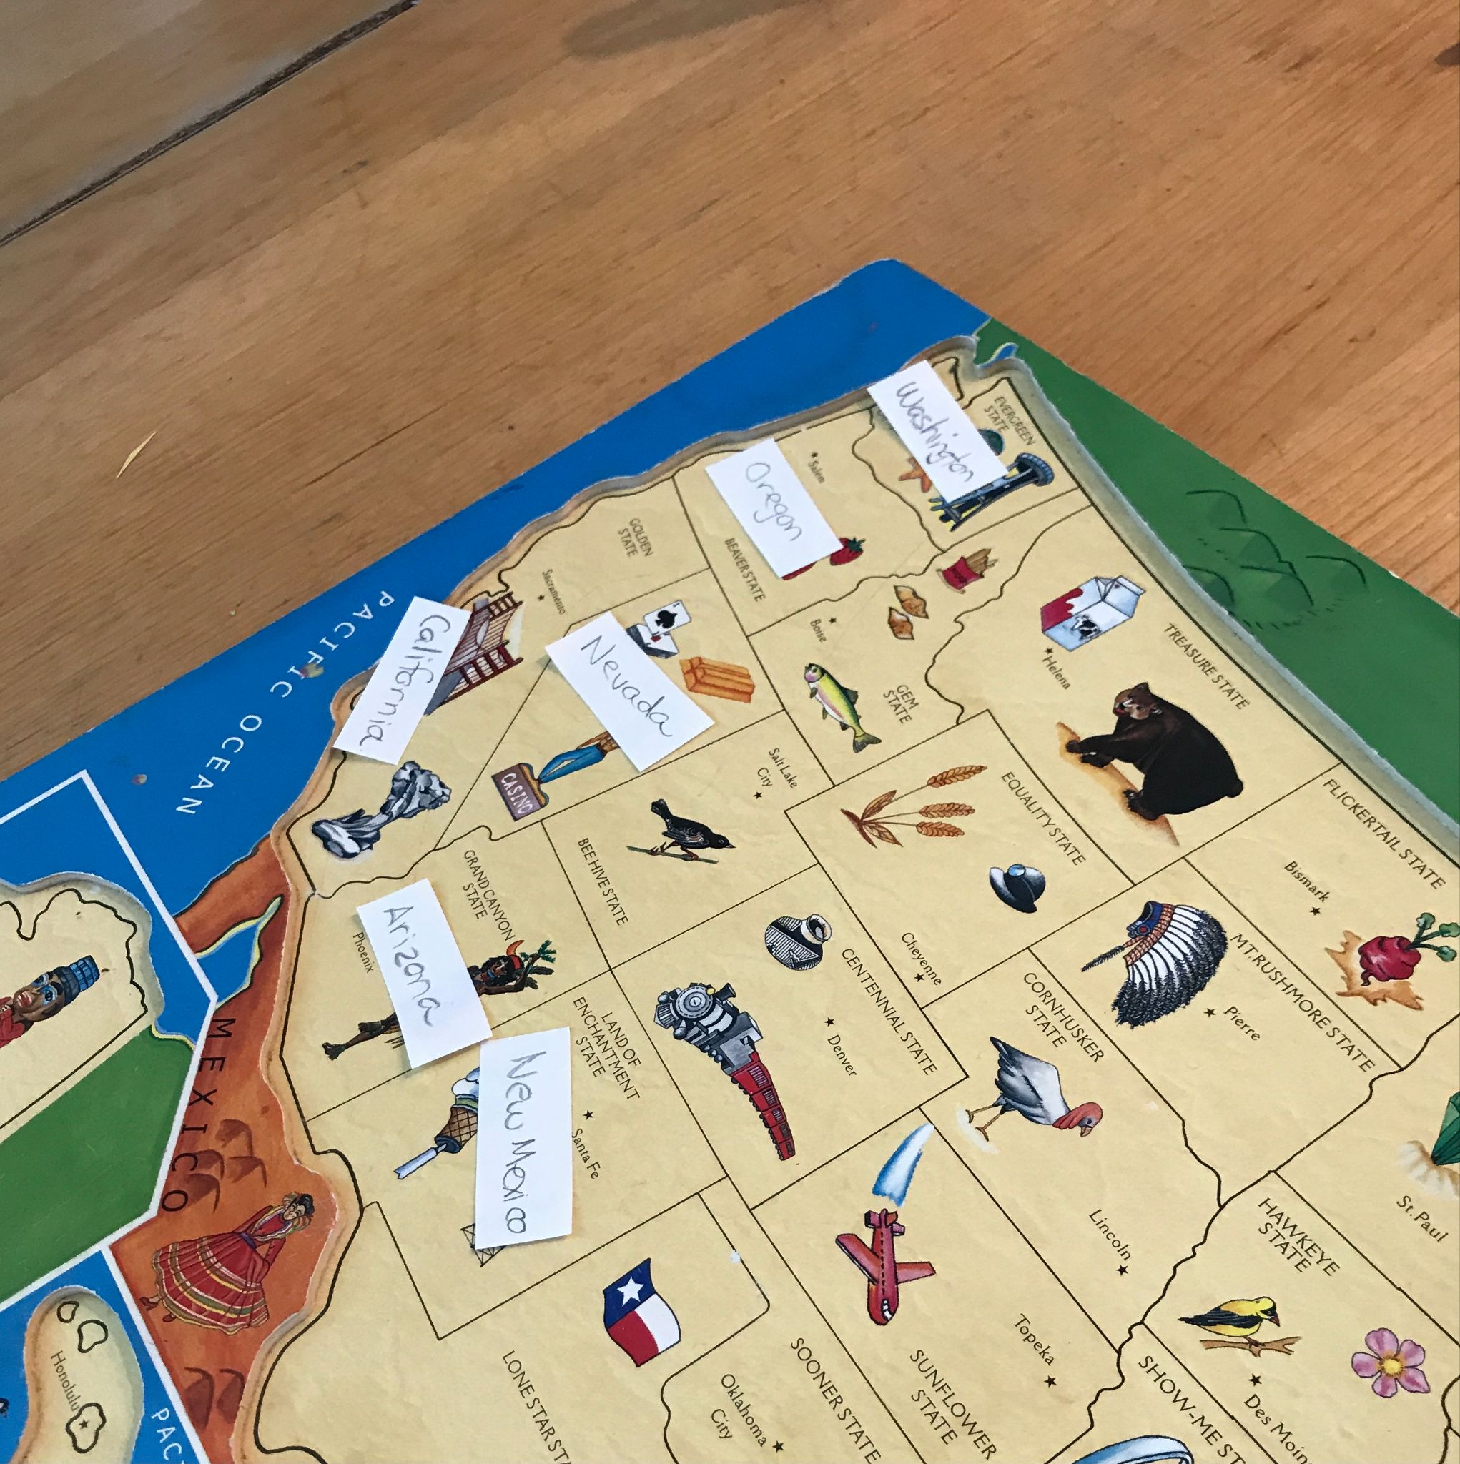
Extension:

Explore each state’s state symbol (flower, coat of arms). It can be fun to play states bingo to identify each state, or play matching games for the states’ flower and coat of arms.

United States bingo (variety of options)

